**Program 1. Develop the HTML page named as “Myfirstwebpage.html”. Add the following tags with relevant content.**

**Set the title of the page as “My First Web Page”. Within the body use the following tags:**

1. **Moving text = “Basic HTML Tags”**
2. **Different heading tags (h1 to h6)**
3. **Paragraph**
4. **Horizontal line**
5. **Line Break**
6. **Block Quote**
7. **Pre tag**
8. **Different Logical Style (, , etc..)**

<!DOCTYPE html>

<head>

<title>Anu’s First Web Page</title>

</head>

<body>

<!-- Moving text -->

<marquee><center>Welcome to Web Technology Lab</center></marquee>

<marquee><center>Basic HTML Tags</center></marquee>

<!-- Different heading tags -->

<h1>This is an H1 heading</h1>

<h2>This is an H2 heading</h2>

<h3>This is an H3 heading</h3>

<h4>This is an H4 heading</h4>

<h5>This is an H5 heading</h5>

<h6>This is an H6 heading</h6>

<!-- Paragraph -->

<p>This is a paragraph demonstrating the use of the paragraph tag in HTML.</p>

<!-- Horizontal line -->

<hr>

<!-- Line break -->

<p>This is a line of text before the break.<br>This is a line of text after the break.</p>

<!-- Block Quote -->

<blockquote>

This is a blockquote. It is used to display a quotation or excerpt from another source.

</blockquote>

<!-- Pre tag -->

<pre>

This is preformatted text.

It preserves spaces and line breaks.

</pre>

<!-- Different Logical Style tags -->

<p>This is <b>bold</b> text.</p>

<p>This is <i>italicized</i> text.</p>

<p>This is <u>underlined</u> text.</p>

<p>This is <sup>superscript</sup> text.</p>

<p>This is <sub>subscript</sub> text.</p>

<p>This is <em>emphasized</em> text.</p>

<p>This is <strong>strong</strong> text.</p>

<p>This is <mark>highlighted</mark> text.</p>

<p>This is <small>small</small> text.</p>

<p>This is <del>deleted</del> text.</p>

<p>This is <ins>inserted</ins> text.</p>

<p>This is <code>inline code</code> text.</p>

</body>

</html>

**Output:**

**Program 2. Develop the HTML page named as “Table.html” to display your class time table.**

1. **Provide the title as Time Table with table header and table footer, row-span and col- span etc.**
2. **Provide various colour options to the cells (Highlight the lab hours and elective hours with different colors.)c) Provide colour options for rows.**

<!DOCTYPE html>

<head>

<title>Time Table</title>

<style>

body {

font-family: 'Times New Roman';

}

table {

width: 80%; margin: 20px auto;

border-collapse: collapse;

}

th,

td {

border: 1px solid #ddd; padding: 8px;

text-align: center;

}

th {

background-color: #f4f4f4; color: #d63384;

}

tr:nth-child(even) { background-color: #f9f9f9;

}

tr:nth-child(odd) { background-color: #e6f7ff;

}

.lab-hour {

background-color: #ffcccc;

}

.elective-hour {

background-color: #ccffcc;

}

.highlight {

font-weight: bold; color: #d63384;

}

tfoot {

background-color: #e0e0e0; font-weight: bold;

}

</style>

</head>

<body>

<h1 style="text-align: center;">Time Table</h1>

<table>

<thead>

<tr>

<th>Day/Time</th>

<th>9:00 - 10:00</th>

<th>10:00 - 11:00</th>

<th>11:20 - 12:20</th>

<th>12:20 - 1:15</th>

<th>Lunch Break</th>

<th>2:10 - 3:00</th>

<th>3:00 - 3:45</th>

<th>3:45 - 4:35</th>

</tr>

</thead>

<tbody>

<tr>

<td>Monday</td>

# Type in the Code for your class Time Table here

</tr>

<tr>

<td>Tuesday</td>

# Type in the Code for your class Time Table here

</tr>

<tr>

<td>Wednesday</td>

# Type in the Code for your class Time Table here

</tr>

<tr>

<td>Thursday</td>

# Type in the Code for your class Time Table here

</tr>

<tr>

<td>Friday</td>

# Type in the Code for your class Time Table here

</tr>

<tr>

<td>Saturday</td>

# Type in the Code for your class Time Table here

</tr>

</tbody>

<tfoot>

<tr>

<td colspan="9">End of Timetable</td>

</tr>

</tfoot>

</table>

</body>

</html>

**Output:**

**Program 3 Develop an external style sheet named as “style.css” and provide different styles for h2, h3, hr, p, div, span, time, img & a tags. Apply different CSS selectors for tags and demonstrate the significance of each.**

**Note: make two files *style.css* and *index.html***

**index.html**

**<html>**

**<head>**

**<title>Styled HTML Page </title>**

**<link rel="stylesheet" href="style.css">**

**</head>**

**<body>**

**<h2>Main Heading</h2>**

**<h3>Subheading</h3> mmm**

**<hr>**

**<p>This is a paragraph demonstrating the basic text styling applied by CSS.</p>**

**<div>**

**This is a styled <strong>div</strong> element with padding and a light border. Inside the div, we can also use**

**<span>span elements</span> that have their own styles, like this bold and orange text.**

**</div>**

**<p>Current time: <time>10:30 AM</time></p>**

**<img src="Canara.jpg" alt="CEC logo">**

**<p>Visit <a href="http**[**s://www.w3schools.com/"**](http://www.w3schools.com/)**>w3schools</a> to learn about web programming.</p>**

**<p class="highlight">This paragraph is highlighted with a yellow background.</p>**

**<p class="center">This text is centered using a class selector.</p>**

**<p id="special-paragraph">This is a special paragraph with unique styles applied through an ID selector.</p>**

**</body>**

**</html> style.css**

**\* {**

**margin: 0;**

**padding: 0;**

**box-sizing: border-box;**

**}**

**h2 {**

**color:red; font-size: 30;**

**margin-bottom: 10px;**

**}**

**h3 {**

**color: orange; font-size: 15;**

**margin-bottom: 8px;**

**}**

**hr {**

**border: 0; height: 2px;**

**background-color: blue; margin: 20px 0;**

**}**

**p {**

**font-family: 'Arial', sans-serif; line-height: 1.6;**

**margin: 10px 0;**

**}**

**div {**

**padding: 15px;**

**border: 1px solid black; background-color:blanchedalmond**

**}**

**span {**

**color: brown; font-weight: bold;**

**}**

**time::before { content: 'Alarm Clock PNG Transparent Images - PNG All'; color:greenyellow;**

**}**

**img {**

**margin-left: 15px; height: 100px; width: 100px; border-radius: 8px;**

**box-shadow: 0 4px 8px rgba(0, 0, 0, 0.2);**

**max-width: 100%;**

**}**

**a {**

**text-decoration: none; color: purple;**

**}**

**a:hover { color: blue;**

**text-decoration: underline;**

**}**

**.highlight {**

**background-color: yellow; padding: 3px;**

**}**

**.center {**

**text-align: center;**

**}**

**#special-paragraph { font-size: 25; color: plum;**

**background-color:ghostwhite; padding: 10px;**

**border-left: 5px solid plum;**

**}**

**h2,**

**h3,**

**p {**

**margin-left: 20px;**

**}**

**Output:**

**Main Heading**

1lisisa par")ra;tl-aingIlle basi:texsttytr,gappledbyCSS

**Thisisastyleddn- lm:tmi:withpaddmgmidahghtborda_lnsldt di•;,wecanalsowsp.utlnantsdwbai"tdm011.uSl}ies.lihdnsboldmiorangeu:n**

Cooentline: 10:30AM

.CAi ARA

Visitw3schoos tooamabootwebprogran,mg.

Thsparo,raph • h IJ>;ihtedwrtnayo11owbackgroooo

I

'111s sa speaalparagrap Mlhur1que stylesapplied throJg an**1u**seecto•

1listextiscenle!edusilgaclasssetoctor.

**Program 4. Develop HTML page named as “registration.html” having variety of HTML input elements with background colors, table for alignment & provide font colors & size using CSS styles.**

**registration.html**

**<!DOCTYPE html>**

**<head>**

**<title>Registration Form</title>**

**<style>**

**body {**

**font-family: Arial, sans-serif; background-color: #f0f4f8; margin: 0;**

**padding: 20px; display: flex;**

**justify-content: center; align-items: center; min-height: 100vh;**

**}**

**.container { width: 100%;**

**max-width: 600px; background-color: #fff; padding: 20px;**

**border-radius: 8px;**

**box-shadow: 0 0 10px rgba(0, 0, 0, 0.1); display: flex;**

**flex-direction: column; gap: 20px;**

**}**

**h2 {**

**text-align: center; color: #333;**

**margin: 0;**

**}**

**.form-group { display: flex;**

**flex-direction: column; gap: 5px;**

**margin-bottom: 10px;**

**}**

**label {**

**font-size: 14px; color: #555;**

**}**

**input[type="text"], input[type="email"],**

**input[type="password"], input[type="date"], select,**

**textarea { padding: 10px;**

**border: 1px solid #ccc; border-radius: 4px; font-size: 14px;**

**}**

**.gender-options { display: flex; gap: 10px;**

**align-items: center;**

**}**

**input[type="submit"], input[type="reset"] {**

**padding: 10px 20px; border: none; border-radius: 4px; cursor: pointer;**

**font-size: 16px; flex: 1;**

**}**

**.button-group { display: flex; gap: 10px;**

**justify-content: center;**

**}**

**input[type="submit"] { background-color: #4CAF50; color: white;**

**}**

**input[type="reset"] { background-color: #f44336; color: white;**

**}**

**.form-group textarea { margin-bottom: 10px;**

**}**

**</style>**

**</head>**

**<body>**

**<div class="container">**

**<h2>Registration Form</h2>**

**<form action="#" method="post">**

**<div class="form-group">**

**<label for="firstName">First Name:</label>**

**<input type="text" id="firstName" name="firstName" required>**

**</div>**

**<div class="form-group">**

**<label for="lastName">Last Name:</label>**

**<input type="text" id="lastName" name="lastName" required>**

**</div>**

**<div class="form-group">**

**<label for="email">Email:</label>**

**<input type="email" id="email" name="email" required>**

**</div>**

**<div class="form-group">**

**<label for="password">Password:</label>**

**<input type="password" id="password" name="password" required>**

**</div>**

**<div class="form-group">**

**<label for="dob">Date of Birth:</label>**

**<input type="date" id="dob" name="dob">**

**</div>**

**<div class="form-group">**

**<label>Gender:</label>**

**<div class="gender-options">**

**<input type="radio" id="male" name="gender" value="male">**

**<label for="male">Male</label>**

**<input type="radio" id="female" name="gender" value="female">**

**<label for="female">Female</label>**

**</div>**

**</div>**

**<div class="form-group">**

**<label for="country">Country:</label>**

**<select id="country" name="country">**

**<option value="usa">USA</option>**

**<option value="canada">Canada</option>**

**<option value="uk">UK</option>**

**<option value="india">India</option>**

**</select>**

**</div>**

**<div class="form-group">**

**<label for="bio">Bio:</label>**

**<textarea id="bio" name="bio" rows="4"></textarea>**

**</div>**

**<div class="button-group">**

**<input type="submit" value="Register">**

**<input type="reset" value="Reset">**

**</div>**

**</form>**

**</div>**

**</body>**

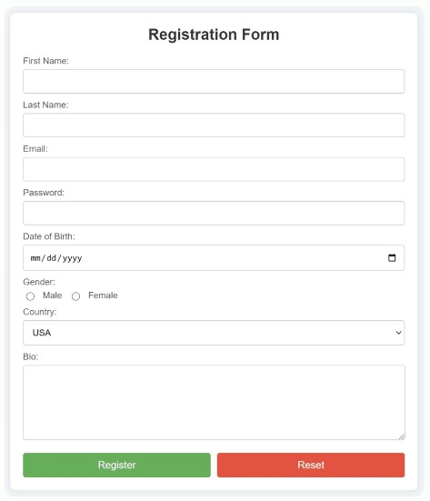**</html> Output:**

**Program 5. Develop HTML page named as “newpaper.html” having variety of HTML semantic elements with background colors, text-colors & size for figure, table, aside, section, article, header, footer… etc.**

<!DOCTYPE html>

<head>

<title>Newspaper Page</title>

<style>

* {

margin: 0;

padding: 0;

box-sizing: content-box;

}

body {

padding: 20px;

font-family: 'Arial', sans-serif; color:black;

display: block;

flex-direction: row; min-height: 100vh;

}

header {

margin-bottom: 30px; border-radius: 10px; align-items: center; background-color:blue; color:whitesmoke; padding: 20px; display: flex;

justify-content:space-between; text-align: center;

}

header a {

font-size: 25px; font-weight: bold; color: white;

text-decoration: none;

}

nav {

display:flex; gap: 50px;

}

nav a {

font-size: 18px; color:black;

text-decoration: none; font-weight: bold;

}

nav a:hover {

text-decoration: underline;

}

.content {

display: flex;

justify-content: space-between; margin: auto;

padding: 20px 0; gap: 20px; position: relative;

}

.main-content { cursor: pointer; display:grid;

grid-template-columns: repeat(auto-fill, minmax(300px, 1fr)); gap: 20px;

background-color:white; border-radius: 12px; padding: 25px;

}

aside {

border: 1px solid brown;

padding: 25px; width: 350px; border-radius: 8px;

position: sticky ; top: 20px; color:red;

right: 0;

margin-left: 10 px; }

.related-news h3 { text-align: center; border-radius: 7px; padding: 8px; background:black; color: white;

margin-bottom: 15px;

}

.related-news ul { list-style: inside; padding: 7px; margin: 0;

}

.related-news li { margin-bottom: 12px;

}

.related-news a {

text-decoration: none; color: blueviolet;

font-weight: bold;

}

.related-news a:hover {

text-decoration: underline;

}

footer {

border-radius: 10px; background-color: brown; color: white;

padding: 20px; font-weight: 500; text-align: center; margin-top: auto; font-size: 18px;

}

article {

background-color: white; padding: 15px;

border-radius: 7px; color: black;

}

figure {

background-color: whitesmoke; padding: 10px;

border: 1px solid gray; border-radius: 8px; text-align: center; margin: 0;

}

figcaption {

font-size: 1.4em; color: palevioletred;

}

img {

max-width: 100%; height: auto; border-radius: 8px;

}

section {

padding: 20px; width: 100%;

background-color:white; border-radius: 8px;

}

section h2 { color:white;

background:burlywood; font-size: 24px;

border-radius: 10px; text-align: center; padding: 10px; margin-bottom: 30px;

}

table {

width: 100%;

border-collapse: separate;

}

caption {

font-size: 18px; margin-bottom: 10px; color: royalblue;

}

thead {

background-color: orangered; color: white;

}

th,

td {

padding: 12px; text-align: left;

}

th {

font-weight: bold;

}

tbody tr:nth-child(odd) { background-color: violet;

}

tbody tr:nth-child(even) { background-color:violet;

}

tbody tr:hover {

background-color: whitesmoke;

}

@media (max-width: 600px) { th,

td {

padding: 8px; font-size: 14px;

}

}

caption {

background-color: grey; padding: 10px;

font-weight: bold;

border-bottom: 2px solid powderblue; border-radius: 8px 8px 0 0;

font-size: 1.1em; color: black;

}

article h2 {

color: blueviolet; font-size: 1.3em;

margin-bottom: 12px;

}

</style>

</head>

<body>

<header>

<a href="#">Newspaper</a>

<nav>

<a href="#">Home</a>

<a href="#">About</a>

<a href="#">Contact</a>

<a href="#">Services</a>

<a href="#">Marketing</a>

<a href="#">Updates</a>

</nav>

</header>

<div class="content">

<main class="main-content">

<article>

<h2>Article Title 1</h2>

<figure>

<img src="https://diplo-media.s3.eu-central-1.amazonaws.com/2024/05/google- mobile-application-smart-phone-screen-1024x683.jpg" alt="Technology">

<figcaption>Google introduces compliance tool for apps and AI</figcaption>

</figure>

<p>First article</p>

</article>

<article>

<h2>Article Title 2</h2>

<figure>

<img src="https://iottechnews.com/wp-content/uploads/2024/10/samsung-knox- matrix-iot-security-smart-home-appliances-internet-of-things.jpeg" alt="Technology">

<figcaption> Knox expands to bolster IoT security</figcaption>

</figure>

<p>Second article</p>

</article>

<article>

<h2>Article Title 3</h2>

<figure>

<img src="https:/[/www.financialexpress.com/wp-](http://www.financialexpress.com/wp-) content/uploads/2024/10/rtatanchand.reuters.jpg?w=1024" alt="Business">

<figcaption>Chandrasekaran pays tribute to Ratan Tata</figcaption>

</figure>

<p>Third article</p>

</article>

</main>

<aside class="related-news">

<h3>Related News</h3>

<ul>

<li><a href="#">Related News 1</a></li>

<li><a href="#">Related News 2</a></li>

<li><a href="#">Related News 3</a></li>

</ul>

</aside>

</div>

<section>

<h2>Recent Posts</h2>

<div>

<table>

<caption>List of Posts</caption>

<thead>

<tr>

<th>Post Title</th>

<th>Date</th>

<th>Author</th>

</tr>

</thead>

<tbody>

<tr>

<td>Post 1</td>

<td>2024-08-30</td>

<td>Author 1</td>

</tr>

<tr>

<td>Post 2</td>

<td>2024-08-29</td>

<td>Author 2</td>

</tr>

</tbody>

</table>

</div>

</section>

<footer>

<p>© 2024 Newspaper. All rights reserved.</p>

</footer>

</body>

</html>

**Output:**

Newspaper H<fflc At>c,o,tl Conu« S,:,,vi.;c-:; M1r1..11n11 IJl:d =

Att1cle Tflle 1 Ametent1e2 An1cle TIiie3

l!» ('(<'fl("'Ml !Wa-«

U• lfCl.fld) .,.1:1

. ta'. (lo)

.-. '-"-"J°·"•'""tr'".."' """'

Attltlll Tfllll 4

f'M• Wltfli/'t

Mll:le- l-l"'-""' ­

_ _.,,,J.-h)Ol *$H60*

--f,lll'n(lolt...-111-

#1_,r. ,H:;,"'

Arllc.k TitlllS

ft-.ll"-00,,ICnl<lll!th-,.:.":k

.-.F,_.t.'.l_t,,.,.)..,.,j,(.,l,,o,u).,..

........

l-- •'fllf"°.

.,_,,_ ,



n»i. «lffllH.Ol"'twlf

-'-'""'"""'-'''"...

- .-:;:"""'

----oln!••---·

·•-"'"'V"'•·-

fl'l1i,1•, •-C111t

...'--"'"-'"'CIOICI_<..

,, ...,._.,......-» $l,<'1'1(1

.•.•-•.•...,:.u.., ,;e1u,1>i.::,.

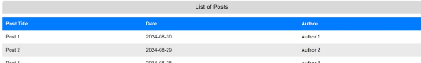

"'

;

,,..., //C/flefll/f l)l,m

ll«atU•- -t'III­

.._

-.W tc.-•.:Sltl_.\1..1._



**Program 6:**

**Apply HTML, CSS and JavaScript to design a simple calculator to perform the following operations: sum, product, difference, remainder, quotient, power, square-root and square.**

<html> <head>

<title>Simple Calculator</title>

<style>

body {

font-family: 'Times New Roman'; display: flex;

justify-content: center; align-items: center; height: 100vh; margin: 0;

}

.calculator { background: white; padding: 20px; border-radius: 12px; width: 320px;

text-align: center; h1 {

border-radius: 8px; background: black; font-size: 24px; padding: 10px; color: white;

margin-bottom: 30px;

}

input, select, button {

width: 100%;

margin: 10px 0; padding: 12px;

border: 1px solid green; border-radius: 8px;

font-size: 16px;

box-sizing: border-box;

}

input:focus, select:focus, button:focus {

outline: none; border-color:black;

}

button {

background-color: green; color: white;

border: none; cursor: pointer; font-size: 18px;

}

#result.error { background: orange; border-color: red;

}

#result.success { font-size: 17px; font-weight: bold; color: black;

background: lightpink; border-color: darkcyan; border-radius: 20px; border:1px solid black; padding:15px;

}

</style> </head>

<body>

<div class="calculator">

<h1>Simple Calculator</h1>

<form id="calculator-form">

<input type="number" id="num1" placeholder="Enter first number" required>

<input type="number" id="num2" placeholder="Enter second number" required>

<select id="operation" required>

<option value="">Select Operation</option>

<option value="sum">Sum</option>

<option value="product">Product</option>

<option value="difference">Difference</option>

<option value="remainder">Remainder</option>

<option value="quotient">Quotient</option>

<option value="power">Power</option>

<option value="sqrt">Square Root</option>

<option value="square">Square</option>

</select>

<button type="button" onclick="calculate()">Calculate</button>

</form>

<div id="result"></div>

</div>

<script>

function calculate() {

const num1 = parseFloat(document.getElementById('num1').value);

const num2 = parseFloat(document.getElementById('num2').value); const operation = document.getElementById('operation').value;

let result = '';

let resultClass = 'success';

if (isNaN(num1) || isNaN(num2)) { result = 'Please enter valid numbers.'; resultClass = 'error';

} else {

switch (operation) { case 'sum':

result = `Sum: ${num1 + num2}`; break;

case 'product':

result = `Product: ${num1 * num2}`; break;

case 'difference':

result = `Difference: ${num1 - num2}`; break;

case 'remainder':

result = `Remainder: ${num1 % num2}`; break;

case 'quotient':

if (num2 == 0) {

result = 'Cannot divide by zero'; resultClass = 'error';

} else {

result = `Quotient: ${num1 / num2}`;

}

break; case 'power':

result = `Power: ${Math.pow(num1, num2)}`; break;

case 'sqrt':

if (num1 < 0 || num2 < 0) {

result = 'Square root is not defined for negative numbers'; resultClass = 'error';

} else {

result = `Square Root of ${num1}: ${Math.sqrt(num1)} <br> Square Root of ${num2}: ${Math.sqrt(num2)}`;

}

break;

case 'square':

result = `Square of ${num1}: ${Math.pow(num1, 2)} <br> Square of ${num2}: ${Math.pow(num2, 2)}`;

break;

default:

result = 'Please select an operation.'; resultClass = 'error';

}

}

const resultDiv = document.getElementById('result'); resultDiv.innerHTML = result; resultDiv.classList.remove('show', 'error', 'success'); resultDiv.classList.add(resultClass, 'show');

}

</script>

</body>

</html>

**Output:**

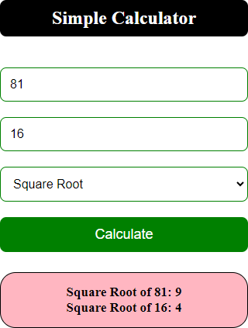

**Program 7: Develop JavaScript program (with HTML/CSS) for:**

1. **Converting JSON text to JavaScript Object**
2. **Convert JSON results into a date**
3. **Converting From JSON To CSV and CSV to JSON**
4. **Create hash from string using crypto.createHash() method**

<html> <head>

<script src="https://cdnjs.cloudflare.com/ajax/libs/crypto-js/4.1.1/crypto- js.min.js">

</script> <title>Simple Converter</title>

<style>

* { padding: 0;

margin: 0;

box-sizing: border-box;

}

body {

font-family: Arial, sans-serif; color: black;

}

.container {

width: 60%;

margin: 0 auto; padding: 20px;

}

.head-title h1 { font-size: 28px; width:100%;

background: pink; padding: 10px; color:black;

margin-bottom: 50px; border-radius: 10px; text-align: center;

}

.section {

margin-bottom: 40px;

padding: 20px; border-radius: 8px;

background: whitesmoke; color:black;

font-size: 20px;

}

textarea {

font-size: 30px; width: 100%; height: 120px;

margin-bottom: 15px; padding: 12px; border-radius: 8px;

border: 1px solid grey; box-sizing: border-box;

}

input[type="text"] { width:100%; padding: 12px; border-radius: 8px;

border: 1px solid blueviolet; box-sizing: border-box;

}

button {

display: inline-block; padding: 15px 15px; margin: 10px 0;

font-weight: bold; border: none; border-radius: 7px;

background-color:blue; color: white;

cursor: pointer; font-size: 16px;

}

.error {

margin-top: 10px; font-size: 14px; color: black; background: plum; border-color: red; padding: 10px;

}

.success {

margin-top: 10px; font-size: 14px;

color:black;

background: powderblue; border-color: brown; padding: 10px;

}

</style> </head> <body>

<div class="container">

<div class="head-title">

<h1>Simple Converter</h1>

</div>

<div class="section">

**<h2>1. Convert JSON Text to JavaScript Object</h2>**

<textarea id="jsonInput" placeholder="Enter JSON here..."></textarea>

<button onclick="convertJsonToObject()">Convert JSON</button>

<pre id="jsonOutput" class="output"></pre>

</div>

<div class="section">

**<h2>2. Convert JSON Results into Date</h2>**

<textarea id="jsonDateInput" placeholder='Enter JSON with date in "yyyy-mm-dd" format'></textarea>

<button onclick="convertJsonToDate()">Convert to Date</button>

<pre id="jsonDateOutput" class="output"></pre>

</div>

<div class="section">

**<h2>3. Convert JSON to CSV and CSV to JSON</h2>**

<textarea id="jsonCsvInput" placeholder="Enter JSON for CSV conversion..."></textarea>

<button onclick="convertJsonToCsv()">JSON to CSV</button>

<pre id="csvOutput" class="output"></pre>

<textarea id="csvInput" placeholder="Enter CSV here..." class="adjust- area"></textarea>

<button onclick="convertCsvToJson()">CSV to JSON</button>

<pre id="jsonCsvOutput" class="output"></pre>

</div>

<div class="section">

**<h2>4. Create Hash from String</h2>**

<input type="text" id="hashInput" placeholder="Enter string to hash">

<button onclick="createHash()">Create Hash</button>

<pre id="hashOutput" class="output"></pre>

</div>

</div> <script>

function **showResult**(id, text, isSuccess) {

const element = document.getElementById(id); element.textContent = text;

element.className = isSuccess ? 'success' : 'error'; element.style.display = 'block';

element.style.opacity = '1';

}

function **convertJsonToObject**() {

const jsonInput = document.getElementById('jsonInput').value; try {

const jsonObject = JSON.parse(jsonInput); showResult('jsonOutput', JSON.stringify(jsonObject, null, 2), true);

} catch (error) {

showResult('jsonOutput', 'Invalid JSON', false);

}

}

function **convertJsonToDate**() {

const jsonDateInput = document.getElementById('jsonDateInput').value; try {

const data = JSON.parse(jsonDateInput);

if (data.date && !isNaN(new Date(data.date).getTime())) { const date = new Date(data.date); showResult('jsonDateOutput', date.toString(), true);

} else {

showResult('jsonDateOutput', 'Invalid Date Format', false);

}

} catch (error) {

showResult('jsonDateOutput', 'Invalid JSON', false);

}

}

function **convertJsonToCsv**() {

const jsonInput = document.getElementById('jsonCsvInput').value; try {

const jsonArray = JSON.parse(jsonInput);

if (Array.isArray(jsonArray) && jsonArray.length > 0) { const keys = Object.keys(jsonArray[0]);

const csv = [ keys.join(','),

...jsonArray.map(row => keys.map(key => JSON.stringify(row[key])).join(','))

].join('\n'); showResult('csvOutput', csv, true);

} else {

showResult('csvOutput', 'Invalid JSON: Expected an array with objects.', false);

}

} catch (error) {

showResult('csvOutput', 'Invalid JSON', false);

}

}

function **convertCsvToJson**() {

const csvInput = document.getElementById('csvInput').value; try {

const lines = csvInput.trim().split('\n'); if (lines.length > 1) {

const keys = lines[0].split(','); if (keys.length > 0) {

const jsonArray = lines.slice(1).map(line => { const values = line.split(',');

return keys.reduce((obj, key, index) => { obj[key] = values[index];

return obj;

}, {});

});

showResult('jsonCsvOutput', JSON.stringify(jsonArray, null, 2), true);

} else {

showResult('jsonCsvOutput', 'Invalid CSV: No columns found.', false);

}

} else {

showResult('jsonCsvOutput', 'Invalid CSV: No data found.', false);

}

} catch (error) { showResult('jsonCsvOutput', 'Invalid CSV', false);

}

}

function **createHash**() {

const hashInput = document.getElementById('hashInput').value.trim(); if (hashInput.length > 0) {

const hash = CryptoJS.SHA256(hashInput).toString(); showResult('hashOutput', hash, true);

} else {

showResult('hashOutput', 'Input cannot be empty', false);

}

}

</script> </body></html>

**Input:**

1. **Converting JSON text to JavaScript Object**

{

"name": "Alice",

"age": 30,

"city": "New York"

"date": "2024-09-01"

}

1. **Convert JSON results into a date**

{

"date": "2024-09-01"

}

1. **Converting From JSON To CSV and CSV to JSON**

[

{"name": "Alice", "age": 30, "city": "New York"},

{"name": "Bob", "age": 25, "city": "San Francisco"},

{"name": "Charlie", "age": 35, "city": "Chicago"}

]

name,age,city Alice,30,New York Bob,25,San Francisco Charlie,35,Chicago

1. **Create hash from string using crypto.createHash() method**

Hello, World!

a591a6d40bf420404a011733cfb7b190d62c65bf0bcda32b5d6f3e91be63e1f7 Hello! Good Morning.

**8. a) Develop a PHP program (with HTML/CSS) to keep track of the number of visitors visiting the web page and to display this count of visitors, with relevant headings.**

**WebPageVisitCount.php**

<?php

$counterFile = "counter.txt";

*// Check if the counter file exists*

if (!file_exists($counterFile)) {

file_put_contents($counterFile, "0"); *// Create the file and initialize with 0*

}

*// Read the current count from the file*

$currentCount = file_get_contents($counterFile);

*// Increment the count by 1*

$newCount = $currentCount + 1;

*// Write the new count back to the file*

file_put_contents($counterFile, $newCount);

?>

<html>

<head>

<title>Visitor Counter</title>

<style> h1 {

font-size: 15px; margin: 0;

}

</style>

</head>

<body>

<h1>Welcome to Our Website!</h1>

<p>You are visitor number: <strong><?php echo $newCount; ?></strong></p>

</div>

</body>

</html>

**Instructions to run the .php file:**

1. Create a file name called **WebPageVisitCount.php**, copy the below code and paste it and save it.
2. Copy **WebPageVisitCount**.php file and open XAAMP directory if installed else install it
3. There you’ll find a folder named “**htdocs**”.
4. Inside the “**htdocs**” folder, paste **WebPageVisitCount**.php file.
5. Then open your XAAMP and start the Apache server.
6. Open your browser; either Google Chrome or Mozilla Firefox.
7. Then, go to the URL “[**http://localhost/WebPageVisitCount.php**](http://localhost/WebPageVisitCount.php)”.

**Output:**

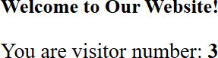

1. **b. Develop a PHP program (with HTML/CSS) to sort the student records which are stored in the database using selection sort.**

**StudentsRecordSort.php**

<?php

$conn = mysqli_connect("localhost","root","","student") or die("can't connect".mysqli_error());

$res = mysqli_query($conn,"select * from studentinfo"); echo "********Before Sorting*********<br/><br/>"; echo "<table border=1>

<tr><th>id</th>

<th>name</th>

<th>usn</th>

<th>branch</th>

<th>email</th>

<th>city</th></tr>";

$a=array(); while($row=mysqli_fetch_row($res))

{

echo "<tr><td>$row[0]</td><td>$row[1]</td><td>$row[2]</td><td>$row[3]</td><td>$row[4]</td>

<td>$row[5]</td></tr>"; array_push($a,$row[2]);

}

echo "</table><br/>";

$n = count($a);

for ($i = 0; $i < $n - 1; $i++)

{

$pos = $i;

for ($j = $i + 1; $j < $n; $j++)

{

if ($a[$pos] > $a[$j])

$pos = $j;

}

if($pos!=$i)

{

$temp = $a[$i];

$a[$i] = $a[$pos];

$a[$pos] = $temp;

}

}

echo "********After Sorting*********<br/><br/>"; echo "<table border=1>

<tr><th>id</th>

<th>name</th>

<th>usn</th>

<th>branch</th>

<th>email</th>

<th>city</th></tr>";

for ($i = 0; $i < $n; $i++)

{

$res1 = mysqli_query($conn,"select * from studentinfo where usn='$a[$i]'");

$row= mysqli_fetch_row($res1); echo

"<tr><td>$row[0]</td><td>$row[1]</td><td>$row[2]</td><td>$row[3]</td><td>$row[4]</td>

<td>$row[5]</td></tr>";

}

?>

**Instructions to run the .php file:**

1. Create a database called **students** or download or import it.
2. Crete a file called **StudentsRecordSort.php** with the above code and save it.
3. Copy the **StudentsRecordSort.php** file and open and open XAAMP directory if installed else install it.
4. There you’ll find a folder named “**htdocs**”.
5. Inside the “**htdocs**” folder, paste **StudentsRecordSort.php** file.
6. Then open your XAAMP and start the Apache server.
7. Open your browser; either Google Chrome or Mozilla Firefox.
8. Then, go to the URL

“[**http://localhost/**](http://localhost/) **StudentsRecordSort.php**”.

**Output:**

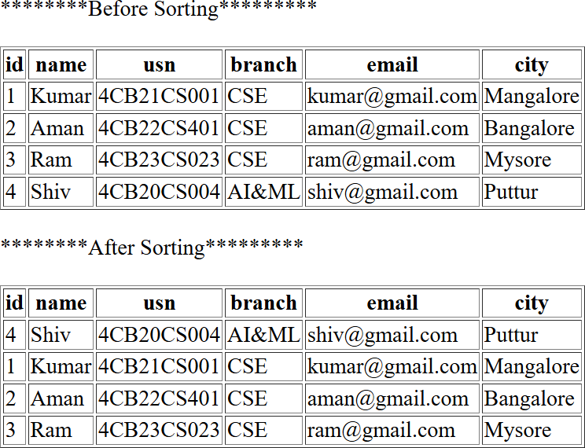

**Student database**

mysql –u root

MariaDB [(none)]>show databases;

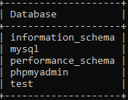

MariaDB [(none)]>create database student; MariaDB [(none)]>show databases;

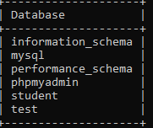

MariaDB [(none)]>use student;



MariaDB [student]> create table studentinfo (id int(11), name varchar(20), usn varchar(20), branch varchar(20), email varchar(50), city varchar(30) );

MariaDB [student]> describe studentinfo;

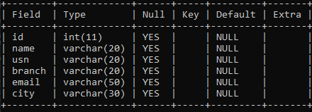

MariaDB [student]> insert into studentinfo values(1, 'Kumar','4CB21CS001','CSE','kumar@gmail.com','Mangalore')

insert into studentinfo values(2, 'Aman','4CB22CS401','CSE','aman@gmail.com','Bangalore'); insert into studentinfo values(3, 'Ram','4CB23CS023','CSE','ram@gmail.com','Mysore'); insert into studentinfo values(4, 'Shiv','4CB20CS004','AI&ML','shiv@gmail.com','Puttur'); insert into studentinfo values(5, 'Shivam','4CB23CS054','CSE','shivam@gmail.com','Udupi');

MariaDB [student]>select * from studentinfo;

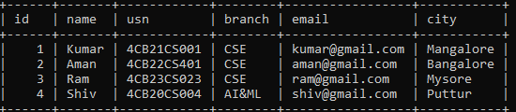

**Program 9.** Develop jQuery script (with HTML/CSS) for:

1. Appends the content at the end of the existing paragraph and list.
2. Change the state of the element with CSS style using animate() method.
3. Change the color of any div that is animated.

<html>

<head>

<script src="https://code.jquery.com/jquery-3.6.0.min.js"></script>

<title>jQuery Example</title>

<style>

button {

padding: 12px 24px; margin: 10px; cursor: pointer; border: none;

border-radius: 6px; font-size: 16px; background: blue; color: white;

}

</style>

</head>

<body>

<div class="container">

<p id="paragraph">This is an existing paragraph.</p>

<ul id="list">

<li>List item 1</li>

<li>List item 2</li>

</ul>

<div class="box" id="box">Animate me!</div>

<button id="appendButton">Append Content</button>

<button id="animateButton">Animate Box</button>

</div>

<script>

$(document).ready(function () {

$("#appendButton").click(function () {

$("#paragraph").append(" Appended text.");

$("#list").append("<li>New appended list item</li>");

});

$("#animateButton").click(function () {

$("#box").stop(true, true).css({ width: "100px",

height: "100px", opacity: 1,

backgroundColor: "blue"

}).animate({ width: "200px", height: "200px", opacity: 0.5

}, 1000, function () {

$(this).css("background-color", "green");

});

});

});

</script>

</body>

</html>

**Output:**

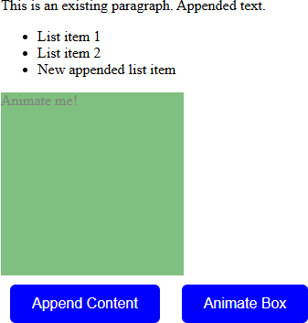

**Program 10. Develop a JavaScript program with Ajax (with HTML/CSS) for:**

1. **Use ajax() method (without Jquery) to add the text content from the text file by sending ajax request.**
2. **Use ajax() method (with Jquery) to add the text content from the text file by sending ajax request.**
3. **Illustrate the use of getJSON() method in jQuery**
4. **Illustrate the use of parseJSON() method to display JSON values. Program:**

**a) Create file:** textfile.txt

**Hello. Good Morning. Have a Nice Day.**

**TenA,html**

<!DOCTYPE html>

<head>

<title>AJAX Examples</title>

</head>

<body>

<h1>AJAX Example-1</h1>

<div id="result"></div>

<button onclick="fetchData()">plain-AJAX</button>

<script>

function fetchData()

{

const xhttp = new XMLHttpRequest(); xhttp.onload = function () {

document.getElementById('result').innerHTML = this.responseText;

}

xhttp.open('GET', 'textfile.txt'); xhttp.send();

}

</script>

</body>

</html>

**Output:**

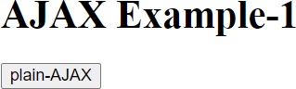

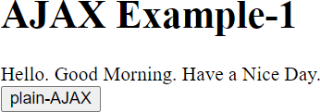

b)

<!DOCTYPE html>

<head>

<script src="https://ajax.googleapis.com/ajax/libs/jquery/3.7.1/jquery.min.js">

</script>

</head>

<body>

<h1>AJAX Example-2</h1>

<div id="output"></div>

<button>jQuery-AJAX</button>

<script>

$(document).ready(function(){

$("button").click(function(){

$("#output").load("textfile.txt");

});

});

</script>

</body>

</html>

**Output:**

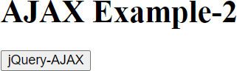

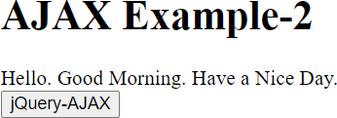

c)

<!DOCTYPE html>

<head>

<script src="https://ajax.googleapis.com/ajax/libs/jquery/3.7.1/jquery.min.js"></script>

</head>

<body>

<h1>AJAX Example-3</h1>

<div id="display"></div>

<input type="button" id="fetch"

value="jQuery-getJSON"/>

<script>

$(document).ready(function(){

$("#fetch").click(function(event){

$.getJSON("data.json", function(emp){

$('#display').html('<p> Name: ' + emp.name + '</p>');

$('#display').append('<p>Age : ' + emp.age + '</p>');

$('#display').append('<p> City: ' + emp.city + '</p>');

});

});

});

</script>

</body>

</html>

data.json

{

"name":"John Doe", "age":30,

"city":"New York"

}

**Output:**

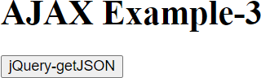

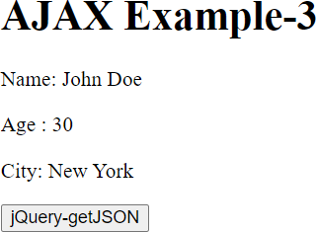

d)

<!DOCTYPE html>

<head>

<script src="https://ajax.googleapis.com/ajax/libs/jquery/3.7.1/jquery.min.js">

</script>

</head>

<body>

<h1>AJAX Example-4</h1>

<div id="a"></div>

<button onclick="parseData()">parseJSON</button>

<script>

function parseData()

{

let txt = '{"name":"John", "age":30, "city":"New York"}' let obj = jQuery.parseJSON(txt); document.getElementById("a").innerHTML =

"Object Name : " + obj.name +

"<br> Object Age : " + obj.age;

}

</script>

</body>

</html>

**Output:**

